**Group Member:**

|  |  |
| --- | --- |
| **Anika Tahsin Raka**  **Ayesha Nasiba** | **20101029(A1)**  **20101026(A1)** |

**Project Name:**

***“Contact Management System*“**

**Brief discussion of the project:**

***“Motivation”***

**The motivation behind our project was to build a contact management system by C programming language. It is a simple console application without graphics, which is similar to the Phonebook of our cell phone.**

***“Features”***

**In this project, we can add, view, edit, search and delete contacts. All added and edited records are saved in a file. We can list contacts by name, phone no. and email**.

**The key features of contact management system are listed below:**

**Add new contacts: With information such as name, phone number and email**

**List all contacts: Lists all the contacts stored in file with their respective contact details**

**Search contacts: Based on name.**

**Edit contacts: Edit information given while adding the contacts – name, phone number and email.**

**Delete contacts: Deletes contacts from file.**

**Our project’s output screen:**

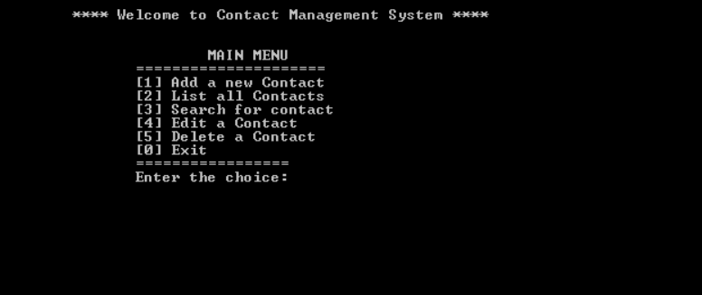

**(Main Menu)**